**Web Programming Assignment # 1**

**Abdullah Jabbar**

**21F-9239**

**Section: 6E**

**Task 1:**

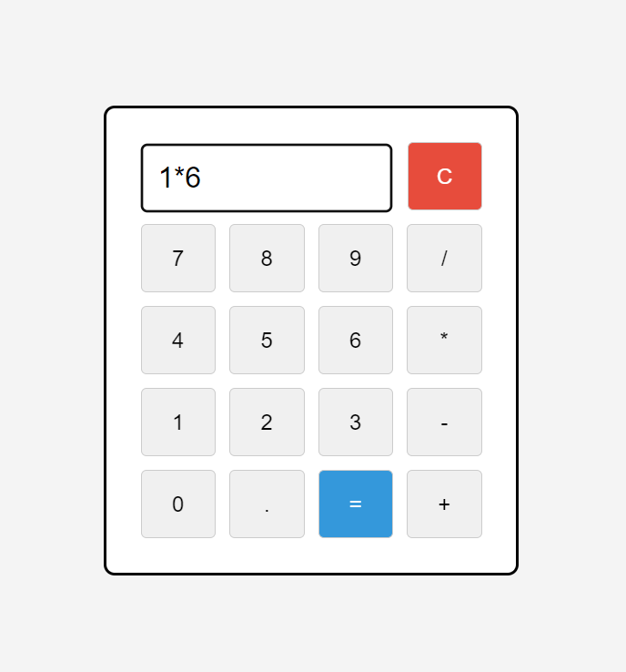

**Task 2:**

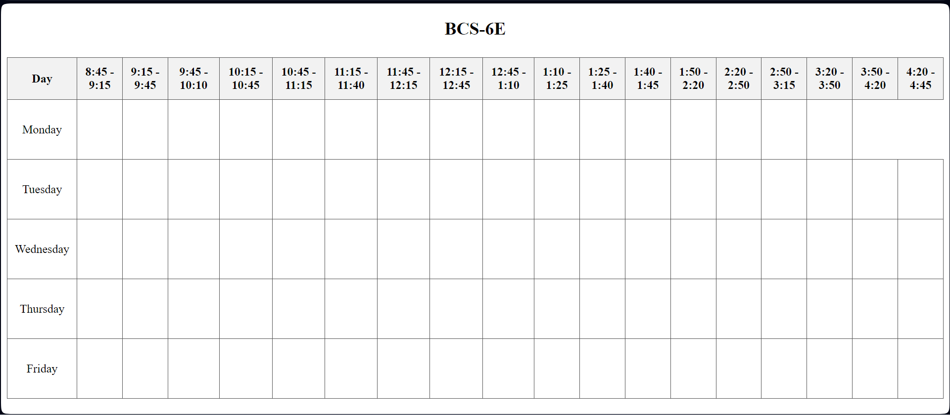

**Task 3:**

